Instructions for teachers

This resource consists of a collection of Action-oriented (AO) Scenarios created by the CEFR Eastern Region Working Group, designed for use in Ontario French as a Second Language (FSL) classrooms. AO Scenarios are an integral part of the Common European Framework of Reference’s (CEFR) Action-oriented Approach (AoA).

The CEFR and the Action-oriented Approach in the Ontario Context

The CEFR is a complete framework used to support learning, teaching, and assessment of second/additional languages. Developed by the Council of Europe, that continent's leading human rights organization, the CEFR has been translated into 40 languages and is used across the world. In 2010, the Council of Ministers of Education, Canada recommended the use of the CEFR in the Canadian context. In Ontario, concepts of the CEFR are integrated throughout the FSL Curriculum.
“Communication is a social act. In order to learn French, therefore, students need to see themselves as social [agents] communicating for real purposes”
(The Ontario Curriculum, FSL, p. 9).

The AoA is one of the key concepts of the CEFR. With the AoA, learners are seen as ‘social agents’ (i.e., someone who exerts their own agency to accomplish real-life tasks). Tasks are critical in the AoA as it is the task that provides the purpose for action, and also frames the learning that takes place within the scenario (i.e., learning module) so that the learner can successfully accomplish the task at hand. The AoA moves away from ‘forward design’ in curriculum planning, instead, favouring ‘backward design’ (Piccardo & North, 2019), which involves planning back from action-oriented tasks (see Figure 1).
“teaching language as a system of disconnected and isolated components gives learners some knowledge of the language, but does not allow them to use the language effectively. In contrast, communicative and action-oriented approaches to teaching French put meaningful and authentic communication at the centre of all learning activities”
(The Ontario Curriculum, FSL, p. 9).

Backward Design
Figure 1: Components of an Action-oriented Scenario
Development of competences  (includes subtasks) | Action-oriented Task


AO Scenarios in this Resource

This resource offers the following AO Scenarios (i.e., AO Task/support material and Subtasks that help the learner to develop the competences needed to accomplish the task) that are aligned with the Ontario Curriculum, and the CEFR:

Grade / Program | CEFR Level | AO Scenario
Grade 4 Core French | A1 | Welcoming a New Student to the Class  (Best used in conjunction with Pearson’s Échos Pro 1)
Grade 5 Core French | A1 | Planning a Fun Afternoon at School  (Best used in conjunction with Pearson’s Échos Pro 2)
Grade 6 Core French | A1 | A Contest to Win Concert Tickets  (Best used in conjunction with Pearson’s Échos Pro 3)
Grade 6 French Immersion / Social Studies | A2 | Les expériences virtuelles - Commemorer la Journée internationale dédiée à la mémoire des l’Holocauste, et apprécier les contributions de la communauté juive au Canada
Grade 7 Core French | A1 | La journée de la santé  (Best used in conjunction with Pearson’s Mon réseau, ma vie 1)
Grade 8 Core French | A1/A2 | Les clubs parascolaires  (Best used in conjunction with Pearson’s Mon réseau, ma vie 2)
Grade 9 Core French  (FSF 1D) | A2 | Organiser une soirée à Montréal
Grade 10 Core French  (FSF 2D) | A2 | Organiser une sortie  (Best used in conjunction with Pearson’s Jusqu’au bout)

Using the Resource

All of the content that has been created can be found on the link CEFR Eastern Region Working Group Website. On the website, you will find information about this group, suggested resources to learn more about the CEFR and the AoA, the above-mentioned AO Scenarios, and information on the Creative Commons licence that applies to the resource.

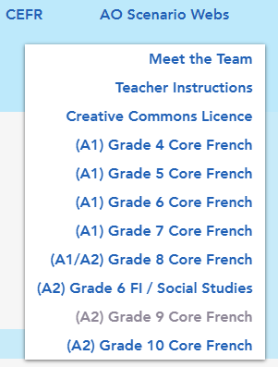
To view a scenario, click the sub-page of the desired grade level from the ‘AO Scenario Webs’ tab (see Figure 2).

Once on the page for the desired AO Scenario, the link to the appropriate Curriculum document will be accessible. In addition, the title of the AO Scenario, a hyperlinked graphic organizer of the AO Scenario, and a link to access the AO Scenario will be visible.

Throughout this resource, the term “Scenario Web” is used. A Scenario Web is a way to conceptualize an AO Scenario. At the centre of the web is the AO Task (e.g., Organiser une soirée à Montréal, Grade 9 Core French) along with the support resources for the AO Task, which lead to ready-to-use/modify documents (see Figure 3 and check an example here). AO Task support materials include:
Figure 2
- AO Teacher Planning Sheet
  - This document provides a description of the task, connections to the Ontario Curriculum, and CEFR descriptors / Student friendly “I can” statements
- AO Task Student View
  - This document provides the AO Task in French, in a student-friendly format
- Assessment Tools
  - Assessment tools are provided to evaluate the components of the AO Task
- Student Planning Sheet
  - This document allows students to monitor their learning throughout the AO Scenario. It is also to be used as a Universal Design for Learning strategy whereby students can ‘chunk’ their learning into more manageable pieces

Around the AO Task and support materials are different threads (e.g., Exploring restaurants, Budgeting). These threads illustrate clusters of possible competences to be developed during the AO Scenario to support students in successfully completing the AO Task (see Figure 4). Each thread is hyperlinked, leading to a table composed of possible subtasks that are designed to build competences connected to a particular area of learning. This table includes links to ready-to-use and/or modify resources, the ‘I can’ statements being targeted, the CEFR communicative language activities and competences that are most prevalent for the sub-task, and possible assessment opportunities based on the four skills of FSL Ontario Curriculum (i.e., Speaking, Listening, Reading, Writing).

IMPORTANT: The threads and the possible subtasks are not presented in any order, and are not intended to be a step-by-step method to planning (unless it is connected to a publisher program). In fact, it is quite the contrary. Key principles of the AoA stipulate that teaching and learning are non-linear, flexible, and dynamic (i.e., changes over time). It is with this in mind that the threads and possible subtasks are presented more like a “bouquet” (Piccardo & North, 2019) whereby teachers pick and choose the ‘flowers’ (i.e., the threads and subtasks) that they would like to include in their bouquet for their students. Students can also play a role in determining the ‘flowers’ to add to the bouquet when sub-tasks are co-created by the teacher and the students.

Figure 3 - Structure of an AO Scenario Web (Grade 9 Example)
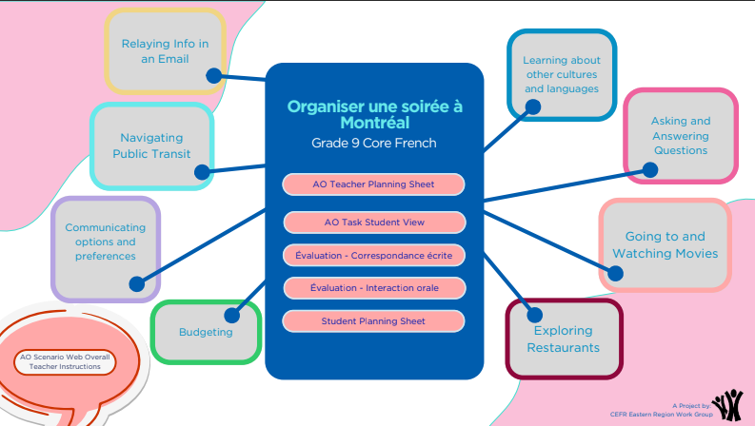

Thread
AO Task and
Support Material

Figure 4 - Table of Possible Subtasks (Grade 9 Example)
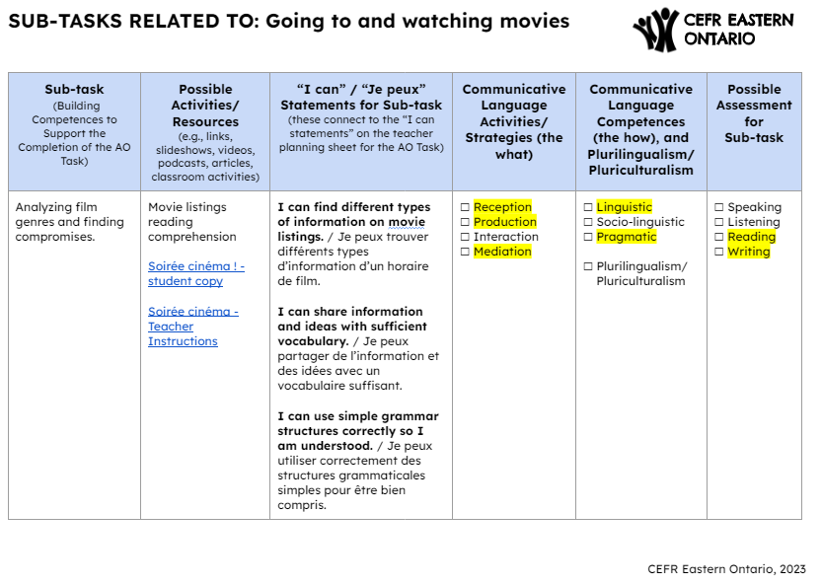
Expanding the AO Scenario Webs

In keeping with the spirit of collaboration, teachers are invited to contribute other possible subtasks using this Google Form, which will be added to the resource (funding dependent). Contributions need to be compliant with copyright laws, with special attention paid to the images used (it is recommended that teachers only use images from the Canva Education licence and that the source be indicated next to the images), and the links provided (do not take screenshots of materials and include them in the submission. Instead, provide a direct link to the resource).

Here is a resource related to copyright, and Creative Commons:

Creative Commons - Share your Work

The notion of “Scenario Webs” is part of Danielle Hunter’s PhD thesis, under the supervision of Dr. Enrica Piccardo

